REPORT ON MICROSOFT CLARITY
A Detailed Report on Blog Site Integration with Microsoft Clarity

Contents

1. Introduction - Microsoft clarity 3
1.1 Introduction: - 3
1.2 Leveraging Heatmaps for Insightful Analysis 3
1.3 Unveiling User Experience Through Session Recordings 3
1.4 Seamless Integration with Google Analytics 3
1.5 Segmenting and Targeting User Groups 4
1.6 Embracing Agility in SEO Strategy 4
1.7 Microsoft Clarity Pros and Cons 4
2. User Interaction Analysis for Blogging Site Website Using Microsoft Clarity 5
2.1 Introduction: 5
2.2 How I set Up My Blog site 5
2.3 Dashboard Features 6
2.4 Identified Key Features: 7
2.5 Data Collection 7
2.6 User Reports 8
I. Recording Session 8
II. User behaviour 9
2.7 User Pattern 9
2.8 Key Takeaway 10
2.9 Google Analytics Report 11
3. References 12

1. Introduction - Microsoft clarity

1.1 Introduction: -

Microsoft Clarity is a robust, free, and open-source application designed to provide comprehensive insights into user behavior on websites. Offering features such as heatmaps, session recordings, and behavioral analytics, it equips website owners with valuable data to optimize user experience and engagement. Integrating seamlessly with Google Analytics, Microsoft Clarity ensures compliance with data privacy regulations like GDPR and CCPA.

- We can break down the functionality into a few key areas: -
- Quick backs - Examine moments users move to a new page but immediately return to the previous one
- Dead clicks - Discover when users click but nothing happens
- Rage clicks - Find out where users rapidly click again and again
- Filter recordings based on sessions where JavaScript errors had been encountered. This allows you to see what the user was doing, before any issues were seen! (Again, getting that balance between stats and understanding of user behavior).
- Filter data based on many different filters (e.g. user location, browser session, etc.). You can then utilize this for ongoing tracking by saving this as a segment.

1.2 Leveraging Heatmaps for Insightful Analysis

Heatmaps generated by Microsoft Clarity offer precise visual representations of user interaction on websites. These heatmaps not only indicate areas of high user engagement but also reveal crucial insights such as scroll depth and click behavior. With three types of heatmaps—click, scroll, and area—website owners can delve deep into user interactions and identify optimization opportunities for improving SEO strategies.

1.3 Unveiling User Experience Through Session Recordings

Session recordings provided by Microsoft Clarity offer a real-time glimpse into user navigation and interaction on websites. While maintaining user anonymity, these recordings illuminate user experiences, highlighting areas of interest as well as potential friction points or technical issues. By understanding user behavior through session recordings, website owners can enhance site usability and mitigate user frustration, ultimately improving engagement.

1.4 Seamless Integration with Google Analytics

The integration of Microsoft Clarity with Google Analytics streamlines the process of analyzing website performance and user behavior. By combining data from both platforms, website owners gain deeper insights into user segments and behaviors, facilitating informed decision-making for SEO optimization and overall website enhancement.

1.5 Segmenting and Targeting User Groups

Dive into the realm of user segmentation with Clarity, enabling targeted analysis of specific user groups based on behavior patterns and recurring errors. By segmenting your audience, you can tailor your optimization efforts to address the unique needs and preferences of different user segments, maximizing the effectiveness of your SEO strategy.

1.6 Embracing Agility in SEO Strategy

Embrace the agile nature of SEO strategy with Microsoft Clarity as your guiding compass. By continuously monitoring user behavior and adapting your approach based on insights gleaned from Clarity's analytics, you can stay ahead of evolving trends and algorithmic updates, ensuring your website remains optimized for superior user experience and search engine visibility

1.7 Microsoft Clarity Pros and Cons

- The Microsoft Clarity Pros
1. It’s free
2. It’s easy to install
3. Microsoft Clarity integrates with Google Analytics
4. It’s GDPR compliant
5. Superior Filtering Capabilities
6. Useful UX metrics
7. Helpful support team
8. Live Demo
9. Clarity Live Extension Plugin
10. Google Optimize Integration

- Microsoft Clarity Cons
1. Lack of detailed documentation for GA integration troubleshooting
2. No “exclude” ability on filters at the time of publication
3. Login confusion if using a shared login

2. User Interaction Analysis for Blogging Site Website Using Microsoft Clarity

2.1 Introduction:

This report delves into user engagement on Gyan Innovative, a dynamic blogging platform dedicated to providing insightful content and fostering knowledge sharing. Leveraging Microsoft Clarity, we scrutinize user interactions to discern popular features and optimize the user experience. Our aim is to deliver concise insights aimed at enhancing productivity and elevating the overall user experience on Gyan Innovative.

2.2 How I set Up My Blog site

- Step 1: Log in to your Microsoft Clarity account.

- Step 2: Navigate to the website you want to track and obtain the tracking code provided by Microsoft Clarity.

- Step 3: Copy the tracking code and paste it inside the <head> tag of the HTML file of your blog site.

- Step 4: I have integrated My Gyan Innovative Vlog site with Microsoft Clarity using a Google Tag manager platform these option is available in Microsoft clarity.

<head>
<script type="text/javascript">
(function(c,l,a,r,i,t,y){
c[a]=c[a]||function(){(c[a].q=c[a].q||[]).push(arguments)};
t=l.createElement(r);t.async=1;t.src="https://www.clarity.ms/tag/"+i;
y=l.getElementsByTagName(r)[0];y.parentNode.insertBefore(t,y);
})(window, document, "clarity", "script", "YOUR-CLARITY-TRACKING-CODE");
</script>
</head>

2.3 Dashboard Features

1. Optimization Insights:
Identify areas for improvement and optimize user experience effortlessly.

2. Visual Analysis Tools:
Session recordings, heatmaps, and click maps provide visual insights into user engagement for easy analysis.

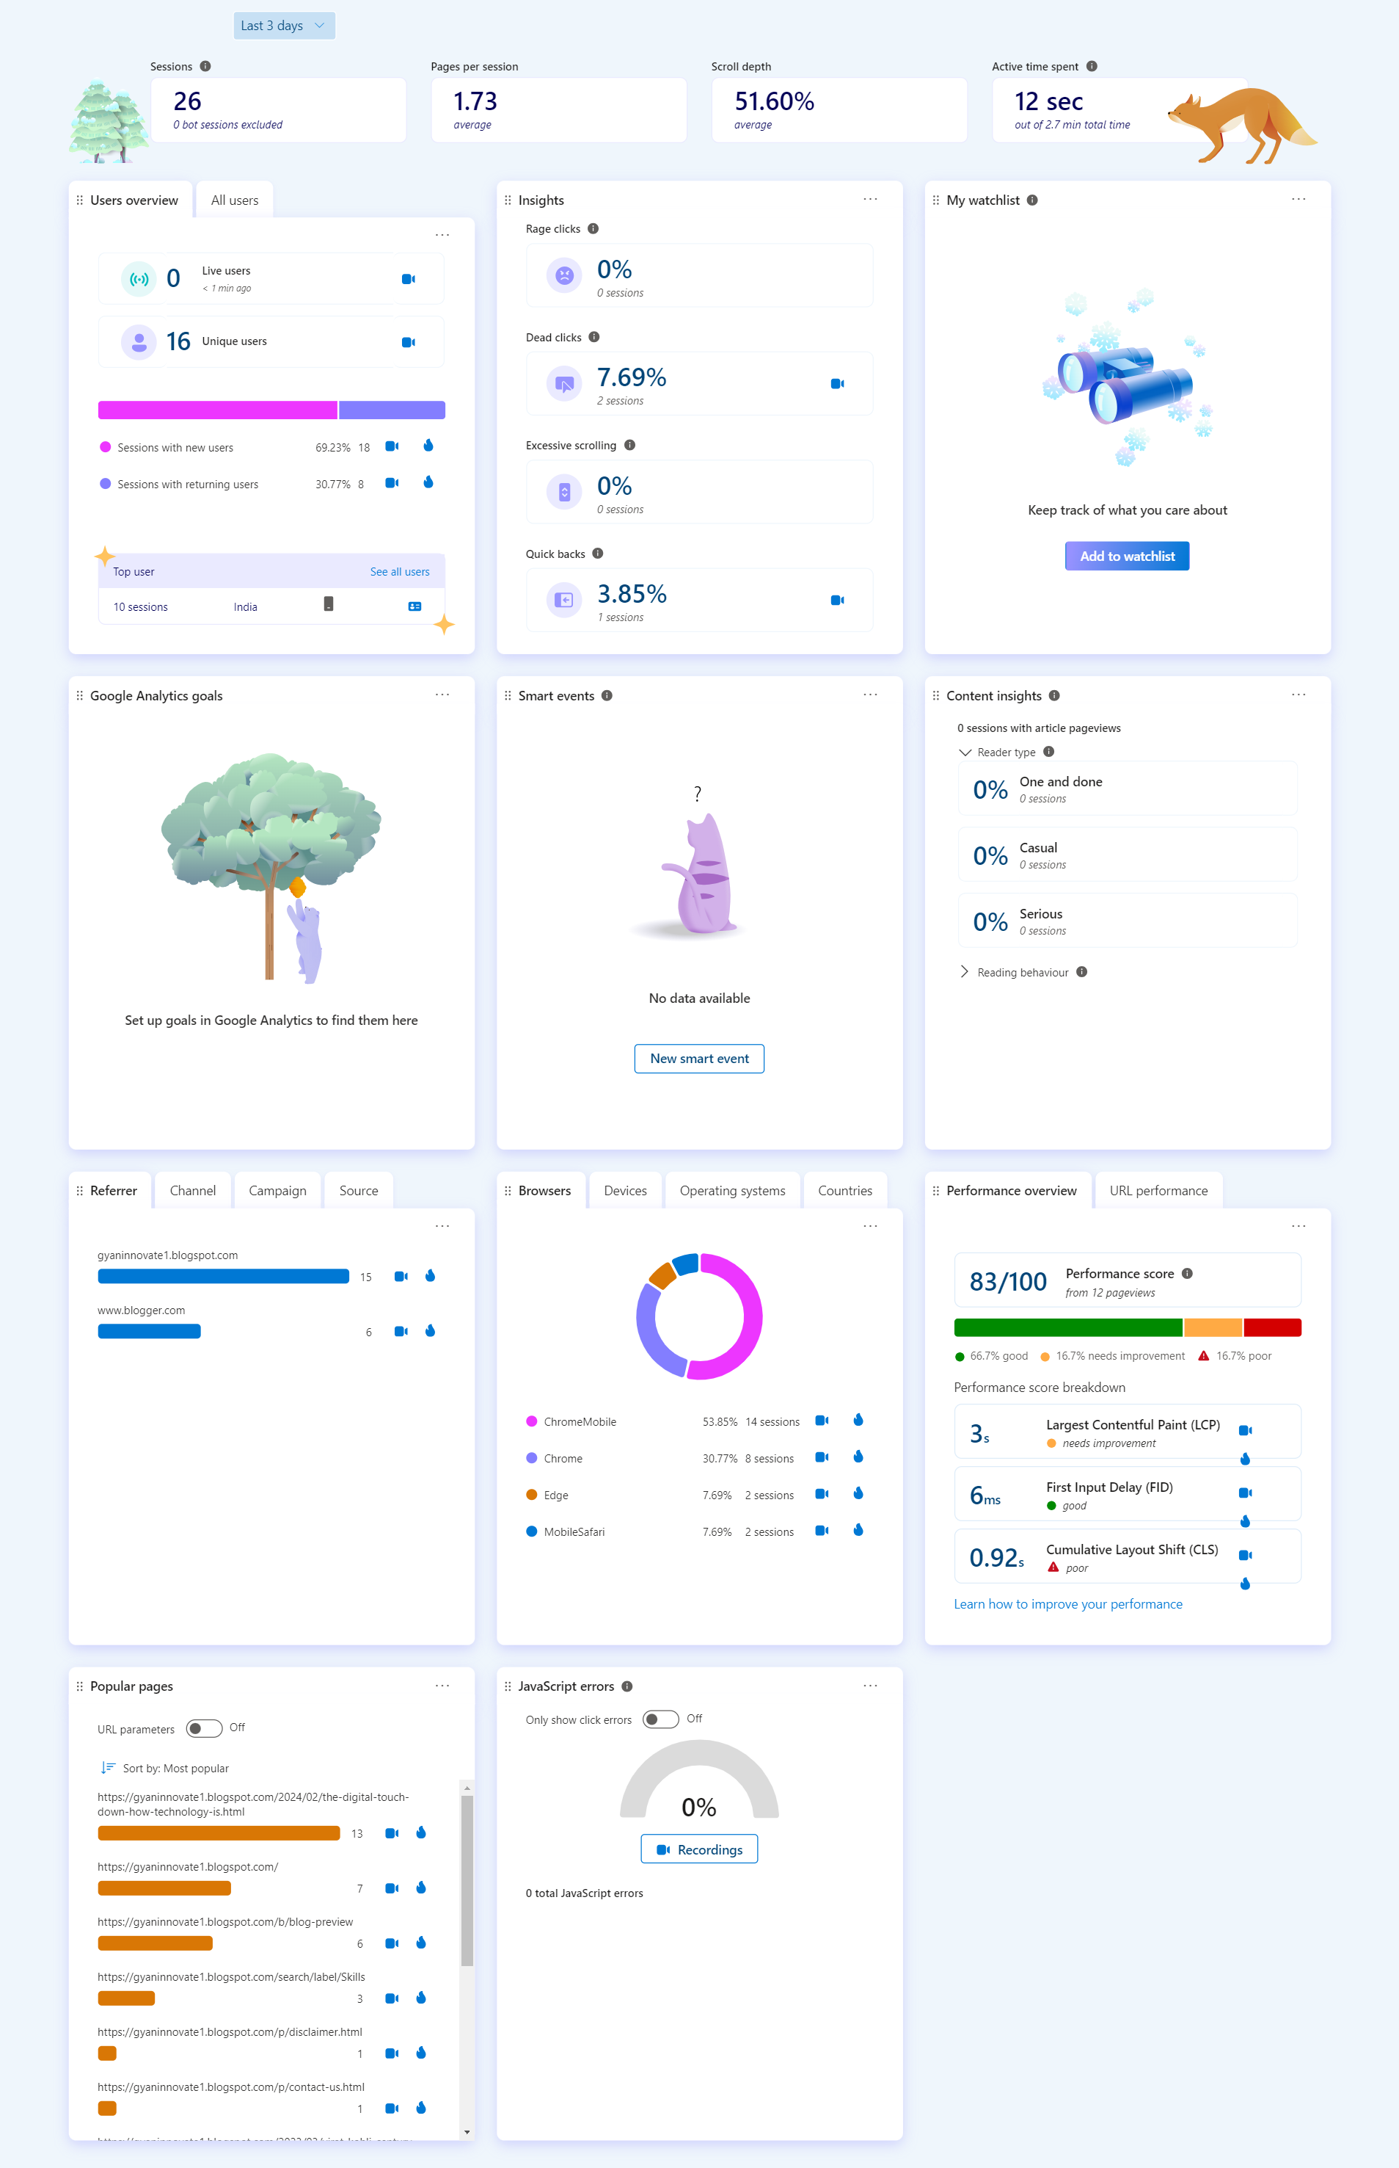

2.4 Identified Key Features:

- This My Website Hosted on Blogger.com Which used For Research Work In Microsoft Clarity: https://gyaninnovate1.blogspot.com
- Through interface analysis of the Gyan Innovative Blog site, the following key
Features /buttons were identified:
- Home Page
- Read Blog on Sports
- Read Blog on Technology
- Contact Page

2.5 Data Collection

Having integrated Microsoft Clarity with our existing webpage, the dashboard provides insightful metrics including the percentage of rage clicks, dead clicks, quick backs, and scroll depth. This data serves as a valuable resource for optimizing our application, enabling us to enhance user experience and refine our platform's performance effectively.

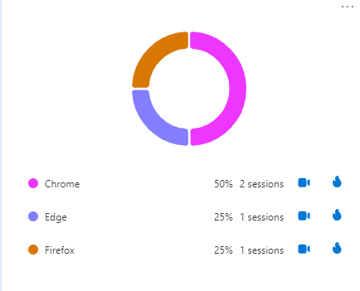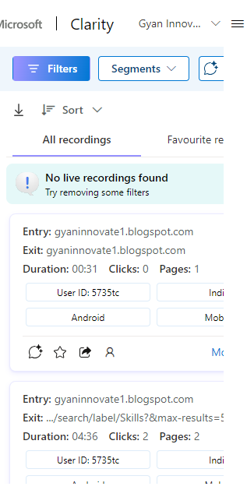

- The data above indicates that the website is accessed by users across various browsers such as Chrome, Edge, and Firefox.
- Additionally, I can demonstrate the features of recorded sessions by showcasing real-time interactions of visitors on the site. This feature enables us to gain valuable insights into user behavior, preferences, and pain points, thereby facilitating informed decision-making for website optimization and enhancement.
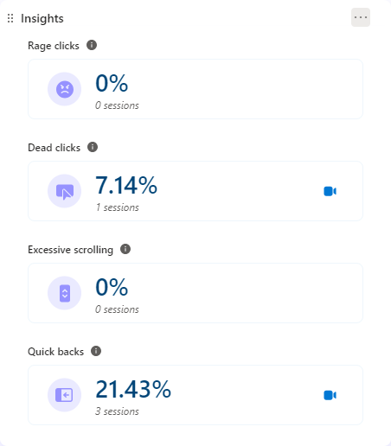
1) Quick backs accounted for 21.43% of user interactions on our website. Quick backs typically signify instances where users navigate to a new page but promptly return to the previous one. This suggests potential issues with content relevance or navigation flow, prompting us to review and optimize the user journey to reduce quick back rates and enhance engagement.

2) Notably, no instances of Rage clicks were recorded, reflecting a positive user experience with minimal frustration

3) Dead clicks accounted for 7.14% of interactions, indicating instances where users clicked on elements but encountered no response. This data suggests potential usability issues or broken functionalities within our website, necessitating further investigation to improve user satisfaction.

2.6 User Reports

Recording Session
Successful User Interactions
- Engagement with Articles: A user was able to successfully read the sports and tech related article titled “Tech Ki Googly” and showed interest in exploring other categories on the website.
- Navigation to Key Pages: A user was able to successfully navigate to the “About Us” and “Contact Us” pages, demonstrating the effectiveness of the site’s navigation. The user also interacted with the site by filling out the contact form.
- Time Spent on Site: A user showed significant interest in the “Skills” category, staying on the website for an extended period of more than four minutes.
Areas for Improvement
- Non-Interactive Elements: Some users attempted to interact with non-clickable elements, such as the menu icon. This indicates a need to clarify which elements are interactive to improve the user experience.
- Navigation Issues: Some users experienced issues when trying to use the browser’s back button to return to the previous page, but ended up staying on the same page. This suggests that the site’s navigation could be improved.

User behaviour

Desktop Users:
- Viewed four blog posts.
- Clicked on titles of three posts: "How to make a website in 10 minutes," "How to start a blog in 2024," and "How to create a logo for free."
- Most content was below the fold, with an average fold position of 688.75 pixels

Mobile Users:
- Viewed 13 blog posts.
- Clicked on various elements including the menu toggle button, footer link "Home," and images/titles of the first two blog posts.
- One user encountered a dead link when clicking on the "About" menu item.
- Most content was also below the fold, with an average fold position of 671.38 pixels.

2.7 User Pattern

- Most Click: - Users have been significantly clicking on the Sports and Technology sections of the website. The Sports blog and the Technology label page have been the most visited, indicating a high level of user interest in these categories. Additionally, the navigation menu has been significantly clicked on, demonstrating its key role in guiding users through the site’s content. These insights are crucial for optimizing the user experience and content strategy.

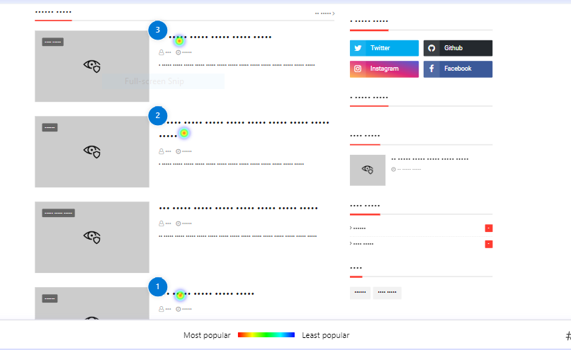
- For desktop users, interaction with the website showed that only half of them reached the third section, and a mere 5% scrolled to the bottom. Interestingly, they attempted to interact with text and images in the first two sections, even though these elements were not designed to be clickable. This indicates a potential area for improvement in the user interface design.
- Mobile users, exhibited a different pattern. They tended to scroll through the entire page. The most interacted elements for mobile users were the download button located in the second section and the footer links leading to the ‘Terms’, ‘About Us’, and ‘Contact Us’ pages.
- The engagement time with the blog content varied among users. While some users spent a significant amount of time (4-5 minutes) reading the blog, others merely visited and left shortly after. This suggests a need for strategies to increase user engagement and reduce bounce rates.

2.8 Key Takeaway
- Adapt the website design to be responsive across different screen sizes and devices. This will improve user engagement and retention. It’s particularly important for showcasing blog posts effectively across different devices and reducing content below the fold.
- Ensure all elements on the website are functional. Dead or unresponsive elements can frustrate users and reduce their trust in the website. Regular optimization is needed to fix any dead links.
- Implement a clear and consistent navigation system. This allows users to easily access different pages and categories, reducing user confusion and the bounce rate.
- Incorporate interactive features such as comments, social media buttons, or related posts. These features can enhance user engagement and retention, encouraging users to interact with the content and spend more time on the page.

- Recommendations for optimizing feature usage

- Introduce engaging and interactive elements such as buttons, sliders, or videos, particularly towards the bottom of your pages. These elements can enhance the user experience, making your website more enjoyable and encouraging users to explore more content.
- Ensure that all design elements function as they appear. If text or images look like buttons or links, they should be clickable. This will prevent user confusion and frustration
- Lastly, consider using heatmaps to visually represent user interactions on your web pages. Heatmaps can highlight areas of high activity such as clicks, scrolls, and mouse movements, providing valuable insights for further optimization. By understanding how users interact with your site, you can make informed decisions to improve the overall user experience. Good luck with your blog site optimization! 😊

2.9 Google Analytics Report
- The website’s audience engagement is growing consistently.
- Most traffic is direct, showing users are actively visiting the site.
- The homepage and tech-focused articles are popular, indicating varied user interests.
- Most users are from India, showing the site’s regional appeal.
- The site is accessed equally via mobile and desktop, highlighting its cross-platform accessibility.
- Overall, analytics show positive user engagement and reach.

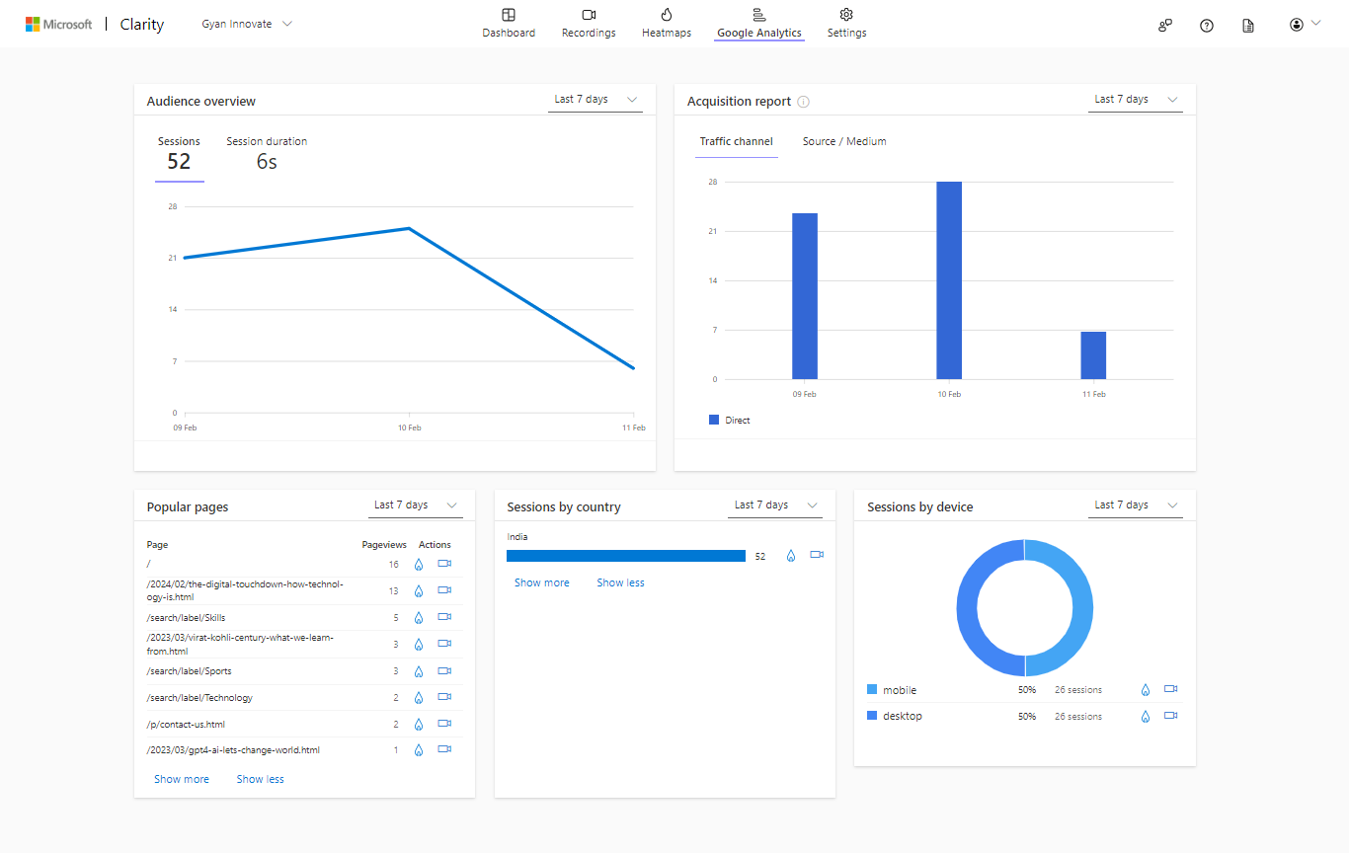

- Google Analytics vs Microsoft Clarity

Aspect | Google Analytics | Microsoft Clarity
Data Collection | Tracks user interactions with cookies. | Offers session replays, heatmaps, and scroll maps.
Features | Comprehensive, including demographics, acquisition sources, and goal tracking. | Focuses on visual insights like session replays and heatmaps.
Ease of Use | Can be complex for beginners. | Offers a user-friendly interface with intuitive visualizations.
Data Privacy | Operates under Google's privacy policies. | Provides options for data masking and compliance with regulations like GDPR and CCPA.
Integration | Integrates well with other Google products. | Provides integration with Microsoft's suite of products.

3. References

- https://clarity.microsoft.com/blog/

- https://www.cloudwithchris.com/blog/insights-with-microsoft-clarity/

- https://youtu.be/FboQ-xfKkP0?si=8IQCMrttD30IDyim

- https://youtu.be/Sc9ctK-vJXc?si=5g9_rgWTHZgkpgl4

- https://www.analyticodigital.com/blog/how-to-setup-microsoft-clarity-with-google-tag-manager

